Software Process Model

Author: Carl

Responsible: Carl

Description: <https://learnit.itu.dk/mod/page/view.php?id=186412>

|  |  |  |  |
| --- | --- | --- | --- |
| Version | Change | Author | Date |
| 0 | Added ChangeLog (change me) | Peter | 22/09 |
|  |  |  |  |
|  |  |  |  |
|  |  |  |  |
|  |  |  |  |
|  |  |  |  |
|  |  |  |  |

**Task:**

**1. Choose the most appropriate agile software process model and write a short text giving the rationale for your choice.**

We have chosen **scrum** as the software process model for our project. We chose this model because it provides a clear framework for the delegation of roles and work in our group and allows every member to have visibility of all tasks currently in progress, thus ensuring that everyone is aligned and on the same page. The short sprint-style of iterative and incremental work is a perfect fit for the toll-gate style of project deliverables that we are expected to provide and allows us to get concurrent feedback on our product and project throughout the process.

Scrum is an extremely popular agile process model and one that most of the team members are already familiar with on various levels. The model is also very well documented given its popularity, so an abundance of resources is available.

*Ressources:* Page 87 in the book,

**2. Briefly, explain the pros. and cons. of the candidate process models to satisfy the key qualities for your case. Please consult with course materials (book, additional readings) for this task. You are also welcome to explore the web for more ideas (I have provided a folder named "Helpful Material" with official sources).**

|  |  |  |
| --- | --- | --- |
|  | **Pros** | **Cons** |
| **Scrum** | Very cross-functional. Self-managed teams. The whole team is accountable in delivering valuable and useful increments every sprint. Small teams (5-10 people). | The method relies heavily on teamwork for a given project to be successful. |
| **Extreme programming** | Test-first development process. Key to define and meet requirements for ease of use and trustworthiness.  These tests are both in the form of automatic tests set up by the developers (based on user stories provided by the customer), and approval testing with the customer after iteration. | Heavily developer focused. Requires team-members to be self-disciplined  It is not as agile as Scrum, meaning that during the iteration of the system, the user is not testing and developing the product alongside the development team, but only does acceptance testing after internal testing. |

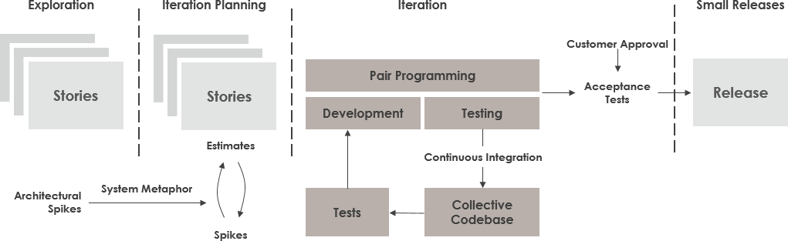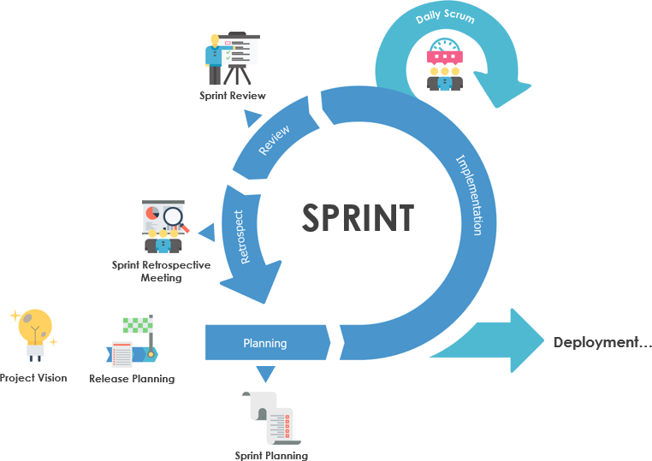

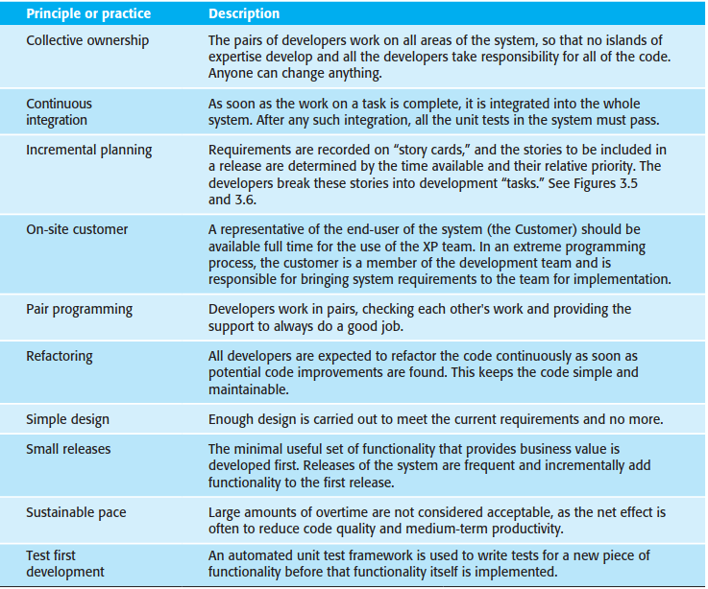

**Outcome:**

Decision made about which development process model to use in the project + rationale for the choice.

**Deadline:**

In time for the next exercise session/supervision meeting.

**Feedback:**

The choice of development model will inform all other project related activities you will implement during the course. The main feedback will therefore be your own experience later.